# Project Based Learning Report

on

DCT based Image compression (JPEG compression) to reduce Image sizes

Submitted in the partial fulfillment of the requirements

For the Project based learning in Digital Signal Processing

In branch

Electronics & Communication

By

## PRN-2114110433 ANSHUMAN

## PRN-2114110436 SAYYAM BAKSHI

**PRN-2114110443 ANAGHA DIXIT**

Under the guidance of Course In charge Dr. M.V.PATIL

Department of Electronic & Communication Engineering

Bharati Vidyapeeth, (Deemed to be University)

College of Engineering, Pune-411043

Academic Year: - 2023-24

## Bharati Vidyapeeth (Deemed to be University) College of Engineering,

**Pune – 411043**

**DEPARTMENT OF ELECTRONICS & COMMUNICATION ENGINEERING**

**CERTIFICATE**

## Certified that the Project Based Learning report entitled, “DCT based Image compression (JPEG compression) to reduce image sizes.” is a bonafide work done by PRN-2114110433 ANSHUMAN

## PRN-2114110436 SAYYAM BAKSHI

## PRN-2114110443 ANAGHA DIXIT

in partial fulfillment of the requirement for the award of credits for Project Based Learning (PBL) in **“DIGITAL SIGNAL PROCESSING”,** of Bachelor of Technology semester V, in Electronics and Communication Engineering.

Date:

Dr. M.V.PATIL Dr. Arundhati Shinde

Course In-charge Head of Department – ECE

# INDEX

|  |  |  |
| --- | --- | --- |
| **S.NO**. | **CONTENT** | **PAGE NO.** |
| 1 | PROBLEM STATEMENT | 1 |
| 2 | INTRODUCTION TO DCT BASED IMAGE COMPRESSION | 1 |
| 3 | THEORY OF IMAGE COMPRESSION USING DCT | 4 |
| 4 | SOURCE CODE FOR REDUCING IMAGE SIZE USING DCT | 6 |
| 5 | ALGORITHM FOR SOURCE CODE OF IMAGE COMPRESSION | 10 |
| 6 | FLOWCHART FOR SOURCE CODE OF IMAGE COMPRESSION | 11 |
| 7 | OUTPUT OF SOURCE CODE | 12 |
| 8 | RESULT AND DISCUSSION OF THE CODE AND IT’S OUTCOME | 17 |
| 9 | CONCLUSION OF THE PROJECT | 20 |
| 10 | REFERENCES | 20 |
| 11 | COURSE OUTCOME | 20 |

**1. PROBLEM STATEMENT**

Design and implement a DCT (Discrete Cosine Transform) based image compression system, following the JPEG (Joint Photographic Experts Group) compression standard, to efficiently reduce the sizes of digital images while preserving acceptable image quality. This project should focus on optimizing the compression algorithm, exploring different compression ratios. Additionally, the system should support various image formats and be adaptable to different image content, ensuring a balance between compression efficiency and image fidelity.

**2. INTRODUCTION**

Image compression is very important for efficient transmission and storage of images. Demand for communication of multimedia data through the telecommunications network and accessing multimedia data through the Internet is growing explosively. With the use of digital cameras, requirements for storage, manipulation, and transfer of digital images, have grown explosively. These image files can be very large and can occupy a lot of memory. A gray scale image that is 256 x 256 pixels has 65, 536 elements to store, and a typical 640 x 480 color image has nearly a million. Downloading of these files from the internet can be a very time-consuming task. Image data comprise a significant portion of the multimedia data and they occupy the major portion of the communication bandwidth for multimedia communication. Therefore development of efficient techniques for image compression has become quite necessary. A common characteristic of most images is that the neighboring pixels are highly correlated and therefore contain highly redundant information. The basic objective of image compression is to find an image representation in which pixels are less correlated. The two fundamental principles used in image compression are redundancy and irrelevancy. Redundancy removes redundancy from the signal source and irrelevancy omits pixel values which are not noticeable by the human eye. JPEG and JPEG 2000 are two important techniques used for image compression.

Work on international standards for image compression started in the late 1970s with the CCITT (currently ITU-T) need to standardize binary image compression algorithms for Group 3 facsimile communications. Since then, many other committees and standards have been formed to produce de jure standards (such as JPEG), while several commercially successful initiatives have effectively become de facto standards (such as GIF). Image compression standards bring about many benefits, such as: (1) easier exchange of image files between different devices and applications; (2) reuse of existing hardware and software for a wider array of products; (3) existence of benchmarks and reference data sets for new and alternative developments.

**Image Compression**

**Need for image compression:**

The need for image compression becomes apparent when a number of bits per image are computed resulting from typical sampling rates and quantization methods. For example, the amount of storage required for given images is (i) a low resolution, TV quality, color video image which has 512 x 512 pixels/color,8 bits/pixel, and 3 colors approximately consisting of 6 x 10⁶ bits;(ii) a 24 x 36 mm negative photograph scanned at 12 x 10⁻⁶mm:3000 x 2000 pixels/color, 8 bits/pixel, and 3 colors nearly contains 144 x 10⁶ bits; (3) a 14 x 17 inch radiograph scanned at 70 x 10⁻⁶mm: 5000 x 6000 pixels, 12 bits/pixel nearly contains 360 x 10⁶ bits. Thus storage of even a few images could cause a problem. As another example of the need for image compression, consider the transmission of low-resolution 512 x 512 x 8 bits/pixel x 3- 3-color video images over telephone lines. Using a 96000 bauds(bits/sec) modem, the transmission would take approximately 11 minutes for just a single image, which is unacceptable for most applications.

**Principles behind compression**:

The number of bits required to represent the information in an image can be minimized by removing the redundancy present in it. There are three types of redundancies: (i)spatial redundancy, which is due to the correlation or dependence between neighboring pixel values; (ii) spectral redundancy, which is due to the correlation between different color planes or spectral bands; (iii) temporal redundancy,which is present because of correlation between different frames in images.Image compression research aims to reduce the number of bits required to represent an image by removing the spatial and spectral redundancies as much as possible.

Data redundancy is of central issue in digital image compression.If n1 and n2 denote the number of information carrying units in original and compressed image respectively ,then the compression ratio CR can be defined as

CR=n1/n2;

And relative data redundancy RD of the original image can be defined as

RD=1-1/CR;

Three possibilities arise here:

1. If n1=n2,then CR=1 and hence RD=0 which implies that original image do not contain any redundancy between the pixels.
2. If n1>>n1,then CR→∞ and hence RD>1 which implies considerable amount of redundancy in the original image.
3. If n1<0 and hence RD→-∞ which indicates that the compressed image contains more data than original image.

**Types of compression:**

Lossless versus Lossy compression: In lossless compression schemes, the reconstructed image, after compression, is numerically identical to the original image. However lossless compression can only a achieve a modest amount of compression. Lossless compression is preferred for archival purposes and often medical imaging, technical drawings, clip art or comics. This is because lossy compression methods, especially when used at low bit rates, introduce compression artifacts. An image reconstructed following lossy compression contains degradation relative to the original. Often this is because the compression scheme completely discards redundant information. However, lossy schemes are capable of achieving much higher compression. Lossy methods are especially suitable for natural images such as photos in applications where minor (sometimes imperceptible) loss of fidelity is acceptable to achieve a substantial reduction in bit rate. The lossy compression that produces imperceptible differences can be called visually lossless.

Predictive versus Transform coding: In predictive coding, information already sent or available is used to predict future values, and the difference is coded. Since this is done in the image or spatial domain, it is relatively simple to implement and is readily adapted to local image characteristics. Differential Pulse Code Modulation (DPCM) is one particular example of predictive coding. Transform coding, on the other hand, first transforms the image from its spatial domain representation to a different type of representation using some well-known transform and then codes the transformed values (coefficients). This method provides greater data compression compared to predictive methods, although at the expense of greater computational requirements

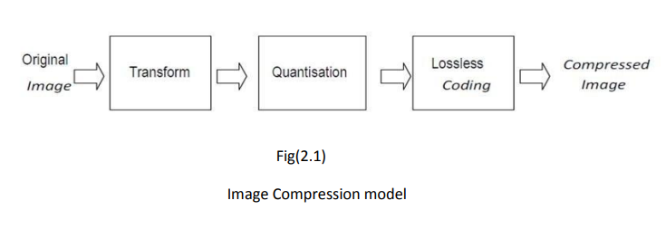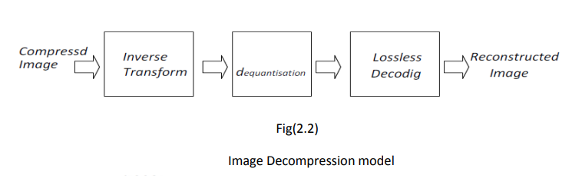

The image compression model shown here consists of a Transformer, quantizer, and encoder.

**Transformer:** It transforms the input data into a format to reduce interpixel redundancies in the input image. Transform coding techniques use a reversible, linear mathematical transform to map the pixel values onto a set of coefficients, which are then quantized and encoded. The key factor behind the success of transform-based coding schemes is that many of the resulting coefficients for most natural images have small magnitudes and can be quantized without causing significant distortion in the decoded image. For compression purpose, the higher the capability. of compressing information in fewer coefficients, the better the transform; for that reason, the Discrete Cosine Transform (DCT) and Discrete Wavelet Transform(DWT) have become the most widely used transform coding techniques.

Transform coding algorithms usually start by partitioning the original image into subimages (blocks) of small size (usually 8 × 8). For each block the transform coefficients are calculated, effectively converting the original 8 × 8 array of pixel values into an array of coefficients within which the coefficients closer to the top-left corner usually contain most of the information needed to quantize and encode (and eventually perform the reverse process at the decoder’s side) the image with little perceptual distortion. The resulting coefficients are then quantized and the output of the quantizer is used by symbol encoding techniques to produce the output bitstream representing the encoded image. In image decompression model at the decoder’s side, the reverse process takes place, with the obvious difference that the dequantization stage will only generate an approximated version of the original coefficient values e.g., whatever loss was introduced by the quantizer in the encoder stage is not reversible.

**Quantizer:** It reduces the accuracy of the transformer’s output in accordance with some pre established fidelity criterion. Reduces the psychovisual redundancies of the input image. This operation is not reversible and must be omitted if lossless compression is desired. The quantization stage is at the core of any lossy image encoding algorithm. Quantization at the encoder side, means partitioning of the input data range into a smaller set of values. There are two main types of quantizers: scalar quantizers and vector quantizers. A scalar quantizer partitions the domain of input values into a smaller number of intervals. If the output intervals are equally spaced, which is the simplest way to do it, the process is called uniform scalar quantization; otherwise, for reasons usually related to minimization of total distortion, it is called non uniform scalar quantization. One of the most popular non uniform quantizers is the Lloyd- Max quantizer. Vector quantization (VQ) techniques extend the basic principles of scalar quantization to multiple dimensions.

**Symbol (entropy) encoder:** It creates a fixed or variable-length code to represent the quantizer’s output and maps the output in accordance with the code. In most cases, a variable-length code is used. An entropy encoder compresses the compressed values obtained by the quantizer to provide more efficient compression. Most important types of entropy encoders used in lossy image compression techniques are arithmetic encoder, huffman encoder and run-length encoder.

**3. THEORY**

**Image Compression using Discrete Cosine Transform**

JPEG stands for the Joint Photographic Experts Group, a standards committee that had its origins within the International Standard Organization (ISO).JPEG provides a compression method that is capable of compressing continuous-tone image data with a pixel depth of 6 to 24 bits with reasonable speed and efficiency.JPEG may be adjusted to produce very small, compressed images that are of relatively poor quality in appearance but still suitable for many applications. Conversely, JPEG is capable of producing very high-quality compressed images that are still far smaller than the original uncompressed data.

JPEG is primarily a lossy method of compression.JPEG was designed specifically to discard information that the human eye cannot easily see. Slight changes in color are not perceived well by the human eye, while slight changes in intensity (light and dark) are. Therefore JPEG's lossy encoding tends to be more frugal with the gray-scale part of an image and to be more frivolous with the color.DCT separates images into parts of different frequencies where less important frequencies are discarded through quantization and important frequencies are used to retrieve the image during decompression. Compared to other input dependent transforms, DCT has many advantages: (1) It has been implemented in single integrated circuit; (2) It has the ability to pack most information in fewest coefficients; (3) It minimizes the block like appearance called blocking artifact that results when boundaries between sub-images become visible.

The forward 2D_DCT transformation is given by the following equation:

C(u,v)=D(u)D(v) 1 0 N x 1 0 N y f(x,y)cos[(2x+1)uπ/2N]cos[(2y+1)vπ/2N]

Where,u,v=0,1,2,3,……………,N-1

The inverse 2D-DCT transformation is given by the following equation:

f(x,y)= 1 0 N u 1 0 N v D(u)D(v)D(u,v)cos[(2x+1)uπ/2N]xcos(2y+1)vπ/2N]

where

D(u)=(1/N) ^1/2 for u=0

D(u)=2(/N)^1/2 for u=1,2,3…….,(N-1)

**JPEG Process:**

* Original image is divided into blocks of 8 x 8.
* Pixel values of a black and white image range from 0-255 but DCT is designed to work on pixel values ranging from -128 to 127 .Therefore each block is modified to work in the range.
* Equation(1) is used to calculate DCT matrix.
* DCT is applied to each block by multiplying the modified block with DCT matrix on the left and transpose of DCT matrix on its right.
* Each block is then compressed through quantization.
* Quantized matrix is then entropy encoded.
* Compressed image is reconstructed through reverse process.
* Inverse DCT is used for decompression.

**Quantization**

Quantization is achieved by compressing a range of values to a single quantum value. When the number of discrete symbols in a given stream is reduced, the stream becomes more compressible.A quantization matrix is used in combination with a DCT coefficient matrix to carry out transformation. Quantization is the step where most of the compression takes place.DCT really does not compress the image because it is almost lossless. Quantization makes use of the fact that higher frequency components are less important than low frequency components. It allows varying levels of image compression and quality through selection of specific quantization matrices. Thus quality levels ranging from 1 to 100 can be selected, where 1 gives the poorest image quality and highest compression, while 100 gives the best quality and lowest compression. As a result quality to compression ratio can be selected to meet different needs.JPEG committee suggests matrix with quality level 50 as standard matrix. For obtaining quantization matrices with other quality levels, scalar multiplications of standard quantization matrix are used. Quantization is achieved by dividing transformed image matrix by the quantization matrix used. Values of the resultant matrix are then rounded off. In the resultant matrix coefficients situated near the upper left corner have lower frequencies .Human eye is more sensitive to lower frequencies .Higher frequencies are discarded. Lower frequencies are used to reconstruct the image.

**Entropy Encoding**

After quantization, most of the high frequency coefficients are zeros. To exploit the number of zeros, a zig-zag scan of the matrix is used yielding to long string of zeros. Once a block has been converted to a spectrum and quantized, the JPEG compression algorithm then takes the result and converts it into a one dimensional linear array, or vector of 64 values, performing a zig-zag scan by selecting the elements in the numerical order indicated by the numbers in the grid below:

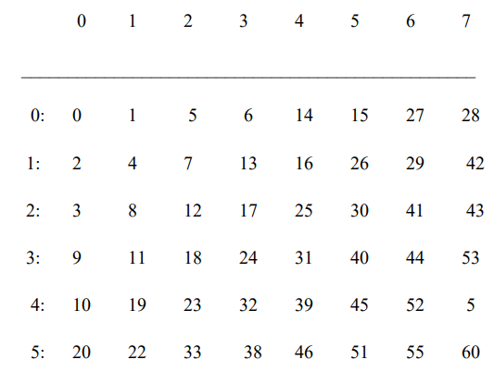

This places the elements of the coefficient block in a reasonable order of increasing frequency. Since the higher frequencies are more likely to be zero after quantization, this tends to group zero values in the high end of the vector.

Huffman coding:The basic idea in Huffman coding is to assign short codewords to those input blocks with high probabilities and long codewords to those with low probabilities.A Huffman code is designed by merging together the two least probable characters, and repeating this process until there is only one character remaining. A code tree is thus generated and the Huffman code is obtained from the labeling of the code tree.

**4. SOURCE CODE**

% Clear the workspace and close all figures

clc;

clear all;

close all;

% List of image file names and corresponding quantization matrices

imageData = {

'1.jpg', [ % Quantization matrix for image 1 (Very High Quality)

200 200 200 200 200 200 200 200;

200 200 200 200 200 200 200 200;

200 200 200 200 200 200 200 200;

200 200 200 200 200 200 200 200;

200 200 200 200 200 200 200 200;

200 200 200 200 200 200 200 200;

200 200 200 200 200 200 200 200;

200 200 200 200 200 200 200 200;

],

'2.jpg', [ % Quantization matrix for image 2 (High Quality)

150 150 150 150 150 150 150 150;

150 150 150 150 150 150 150 150;

150 150 150 150 150 150 150 150;

150 150 150 150 150 150 150 150;

150 150 150 150 150 150 150 150;

150 150 150 150 150 150 150 150;

150 150 150 150 150 150 150 150;

150 150 150 150 150 150 150 150;

],

'3.jpg', [ % Quantization matrix for image 3 (Medium Quality)

100 100 100 100 100 100 100 100;

100 100 100 100 100 100 100 100;

100 100 100 100 100 100 100 100;

100 100 100 100 100 100 100 100;

100 100 100 100 100 100 100 100;

100 100 100 100 100 100 100 100;

100 100 100 100 100 100 100 100;

100 100 100 100 100 100 100 100;

],

'4.jpg', [ % Quantization matrix for image 4 (Low Quality)

50 50 50 50 50 50 50 50;

50 50 50 50 50 50 50 50;

50 50 50 50 50 50 50 50;

50 50 50 50 50 50 50 50;

50 50 50 50 50 50 50 50;

50 50 50 50 50 50 50 50;

50 50 50 50 50 50 50 50;

50 50 50 50 50 50 50 50;

],

'5.jpg', [ % Quantization matrix for image 5 (Very Low Quality)

25 25 25 25 25 25 25 25;

25 25 25 25 25 25 25 25;

25 25 25 25 25 25 25 25;

25 25 25 25 25 25 25 25;

25 25 25 25 25 25 25 25;

25 25 25 25 25 25 25 25;

25 25 25 25 25 25 25 25;

25 25 25 25 25 25 25 25;

],

'6.jpg', [ % Quantization matrix for image 6 (Extremely Low Quality)

10 10 10 10 10 10 10 10;

10 10 10 10 10 10 10 10;

10 10 10 10 10 10 10 10;

10 10 10 10 10 10 10 10;

10 10 10 10 10 10 10 10;

10 10 10 10 10 10 10 10;

10 10 10 10 10 10 10 10;

10 10 10 10 10 10 10 10;

]

};

% Quantization level labels

quantizationLevels = {

'200 Quantization matrix',

'150 Quantization matrix',

'100 Quantization matrix',

'50 Quantization matrix',

'25 Quantization matrix',

'10 Quantization matrix'

};

% Loop through each image and its corresponding quantization matrix

for k = 1:size(imageData, 1)

% Load the image

imageFile = imageData{k, 1};

quantizationMatrix = imageData{k, 2};

I = imread(imageFile);

% Display the original image

figure, imshow(I);

title(['Original Image - ', imageFile]);

% Color space conversion

YCbCr = rgb2ycbcr(I);

Y = double(YCbCr(:,:,1)); % Y channel

Cb = double(YCbCr(:,:,2)); % Cb channel

Cr = double(YCbCr(:,:,3)); % Cr channel

% Use the specified quantization matrix

q80 = quantizationMatrix;

% Compression

[h, w] = size(Y);

r = floor(h/8);

c = floor(w/8);

compressedY = zeros(h, w);

compressedCb = zeros(h, w);

compressedCr = zeros(h, w);

for i = 1:r

for j = 1:c

% Extract 8x8 blocks from each channel

YBlock = Y((i-1)*8+1:i*8, (j-1)*8+1:j*8);

CbBlock = Cb((i-1)*8+1:i*8, (j-1)*8+1:j*8);

CrBlock = Cr((i-1)*8+1:i*8, (j-1)*8+1:j*8);

% Apply DCT and quantization to each block

YDCT = dct2(YBlock - 128);

CbDCT = dct2(CbBlock - 128);

CrDCT = dct2(CrBlock - 128);

YQuantized = round(YDCT ./ q80);

CbQuantized = round(CbDCT ./ q80);

CrQuantized = round(CrDCT ./ q80);

% Store the quantized coefficients in the corresponding positions

compressedY((i-1)*8+1:i*8, (j-1)*8+1:j*8) = YQuantized;

compressedCb((i-1)*8+1:i*8, (j-1)*8+1:j*8) = CbQuantized;

compressedCr((i-1)*8+1:i*8, (j-1)*8+1:j*8) = CrQuantized;

end

end

% Decompression

reconstructedY = zeros(h, w);

reconstructedCb = zeros(h, w);

reconstructedCr = zeros(h, w);

for i = 1:r

for j = 1:c

% Extract quantized coefficients from the compressed image

YQuantized = compressedY((i-1)*8+1:i*8, (j-1)*8+1:j*8);

CbQuantized = compressedCb((i-1)*8+1:i*8, (j-1)*8+1:j*8);

CrQuantized = compressedCr((i-1)*8+1:i*8, (j-1)*8+1:j*8);

% Inverse quantization and IDCT

YDCT = YQuantized .* q80;

CbDCT = CbQuantized .* q80;

CrDCT = CrQuantized .* q80;

YBlock = idct2(YDCT) + 128;

CbBlock = idct2(CbDCT) + 128;

CrBlock = idct2(CrDCT) + 128;

% Store the reconstructed channels

reconstructedY((i-1)*8+1:i*8, (j-1)*8+1:j*8) = YBlock;

reconstructedCb((i-1)*8+1:i*8, (j-1)*8+1:j*8) = CbBlock;

reconstructedCr((i-1)*8+1:i*8, (j-1)*8+1:j*8) = CrBlock;

end

end

% Color space conversion back to RGB

reconstructedYCbCr = cat(3, uint8(reconstructedY), uint8(reconstructedCb), uint8(reconstructedCr));

reconstructedRGB = ycbcr2rgb(reconstructedYCbCr);

figure, imshow(reconstructedRGB);

title(['Reconstructed Image - ', quantizationLevels{k}]);

% Calculate compression ratio

originalSize = numel(Y) + numel(Cb) + numel(Cr);

compressedSize = numel(compressedY) + numel(compressedCb) + numel(compressedCr);

compressionRatio = originalSize / compressedSize;

fprintf('Compression Ratio for %s: %.2f\n', imageFile, compressionRatio);

end

**5. ALGORITHM**

1. Clear the workspace, close all figures, and clear all variables.

2. Define a cell array called "imageData" that contains the names of image files and their corresponding quantization matrices.

3. Define a cell array called "quantizationLevels" that contains labels for the quantization matrices.

4. Loop through each image and its corresponding quantization matrix:

a. Load the image using the imread function.

b. Display the original image using the imshow function.

c. Convert the image from RGB color space to YCbCr color space using the rgb2ycbcr function.

d. Extract the Y, Cb, and Cr channels from the YCbCr image.

e. Use the specified quantization matrix.

f. Perform compression:

- Divide the image into 8x8 blocks.

- Apply the DCT (Discrete Cosine Transform) to each block.

- Quantize the DCT coefficients by dividing them by the quantization matrix and rounding to the nearest integer.

- Store the quantized coefficients in the corresponding positions.

g. Perform decompression:

- Extract the quantized coefficients from the compressed image.

- Inverse quantize the coefficients by multiplying them by the quantization matrix.

- Apply the inverse DCT (IDCT) to each block.

- Store the reconstructed channels.

h. Convert the reconstructed YCbCr image back to RGB color space using the ycbcr2rgb function.

i. Display the reconstructed image.

j. Calculate the compression ratio by dividing the original size of the image (sum of the number of elements in Y, Cb, and Cr channels) by the compressed size of the image (sum of the number of elements in the compressed Y, Cb, and Cr channels).

k. Print the compression ratio for the current image.

**6. FLOWCHART**

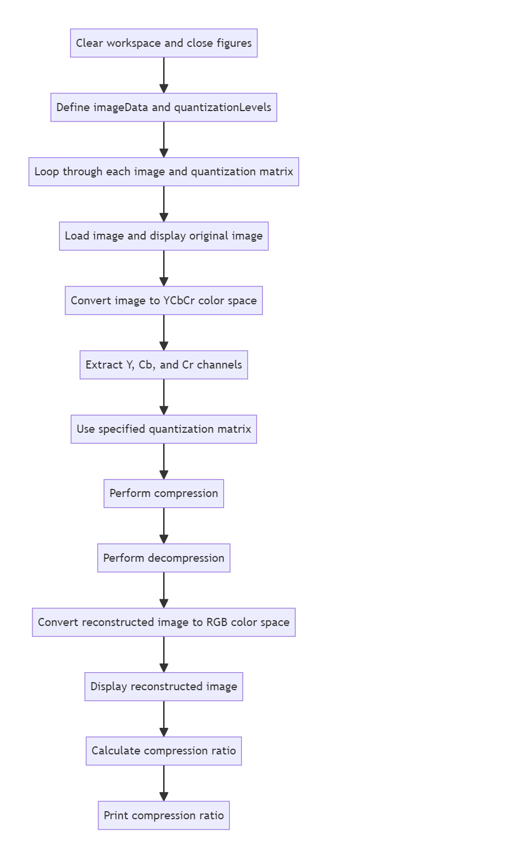

**7. OUTPUT**

1. 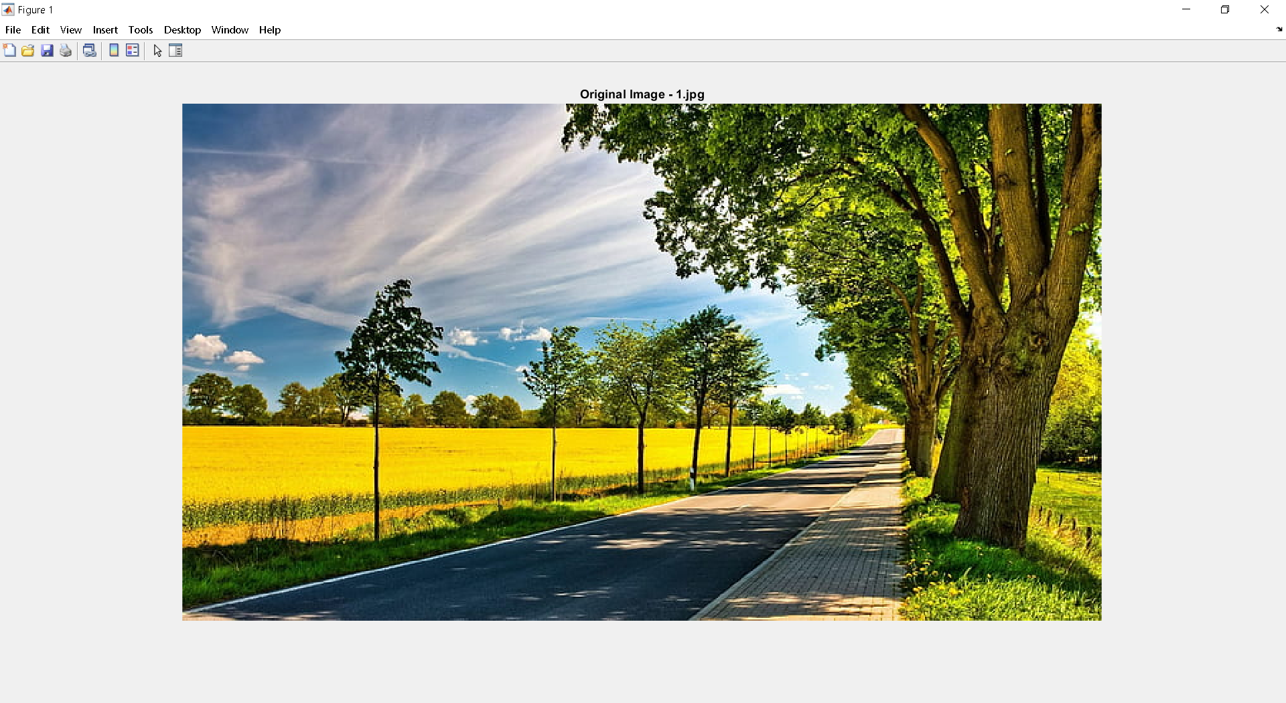**Orignal Image:**

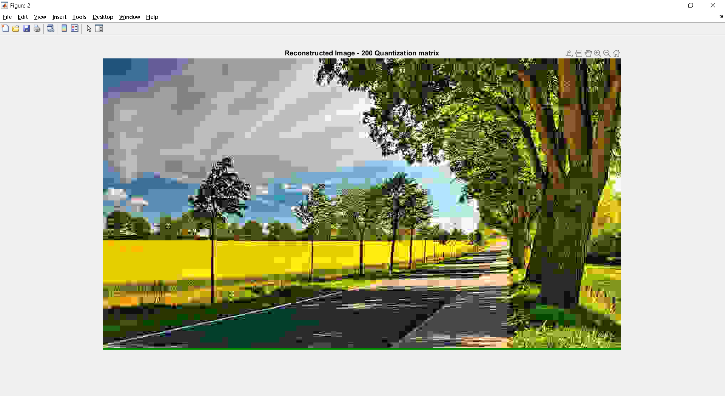

1. **Reconstructed Image with 200 Quantization matrix**
2. 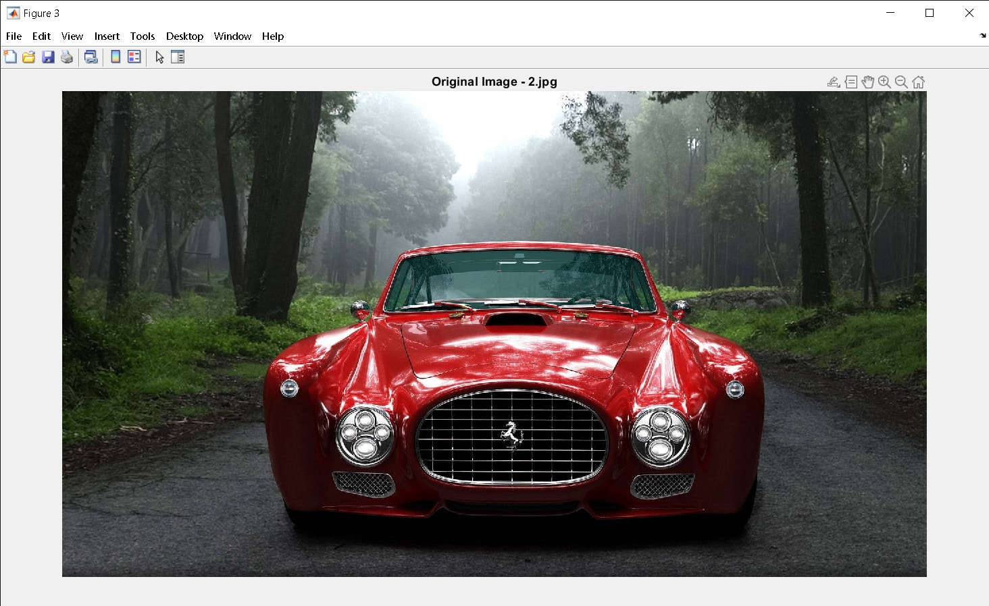**Orignal Image**

**2**) **Reconstructed Image with 150 Quantization matrix**

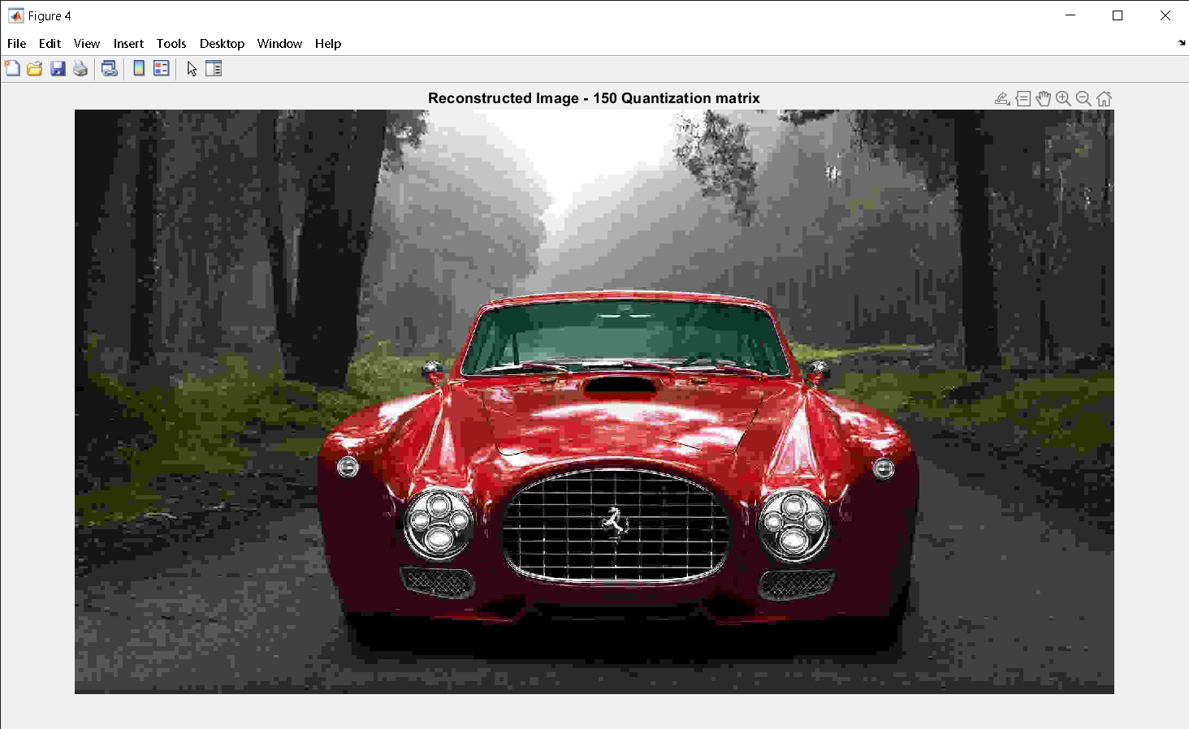

**3)Orignal Image 3)Reconstructed**

**Image with 100 quantization**

**matrix**

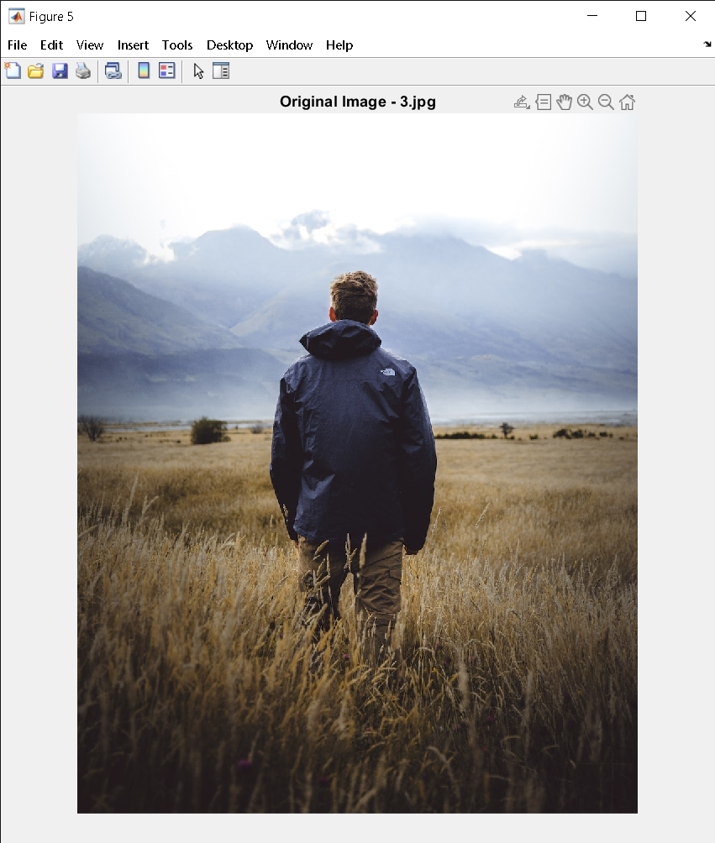

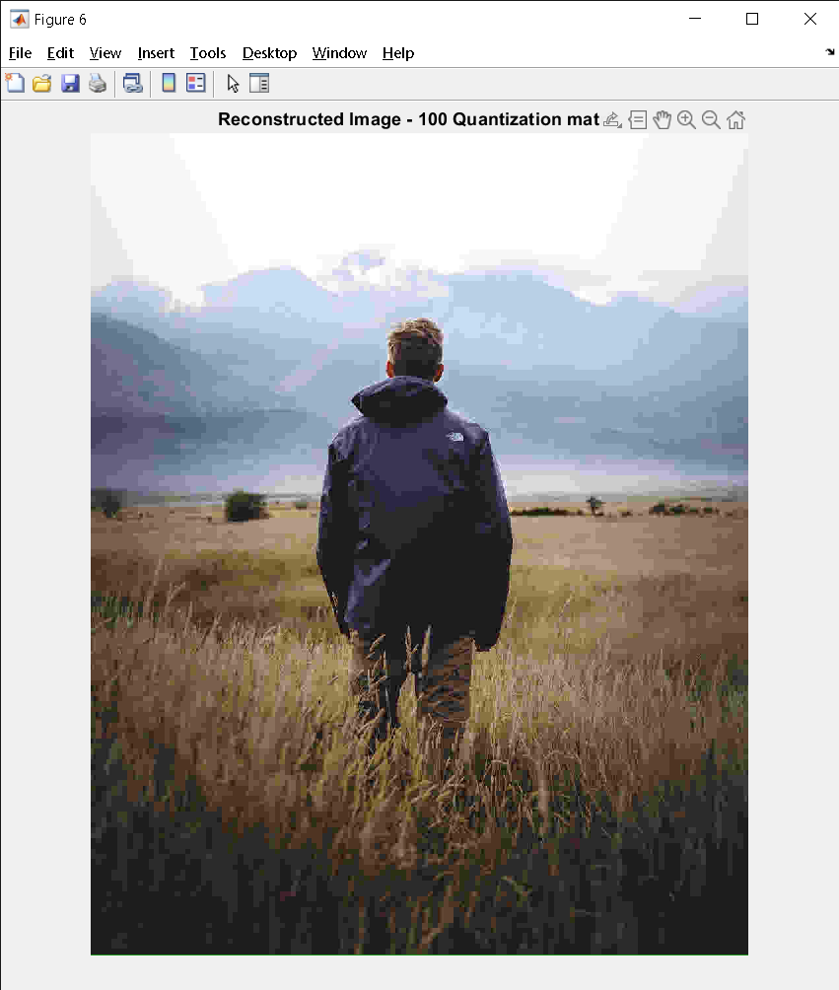

**4**)**Orignal Image 4) Reconstructed image**

**With 50 quantization**

**matrix**

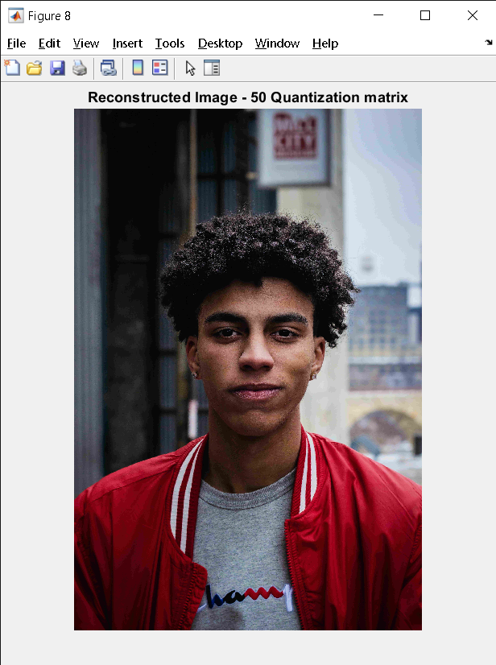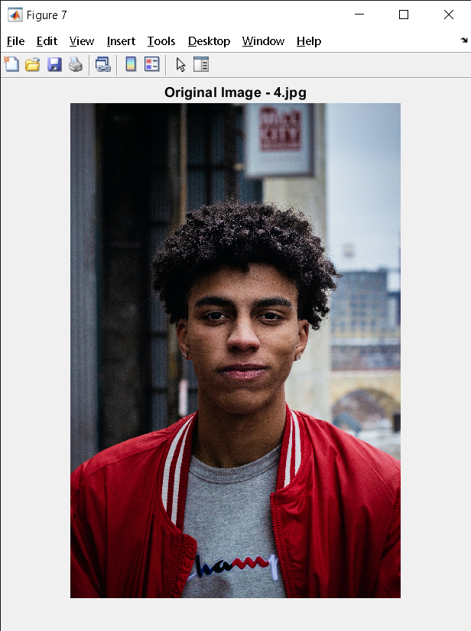

**5**) **Orignal Image**

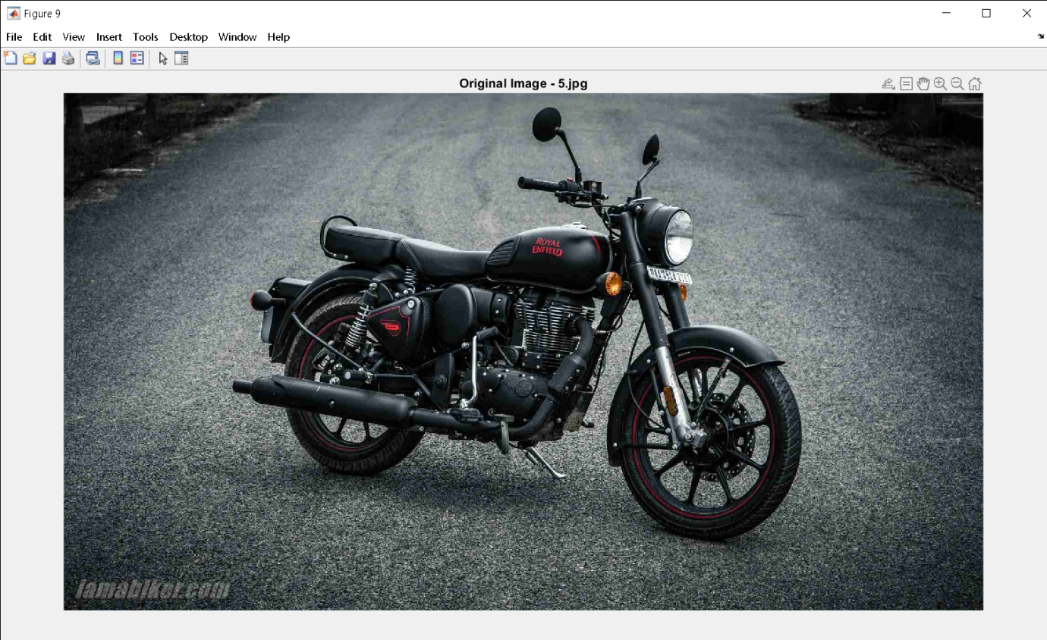

**5) Reconstructed image With 25 quantization matrix**

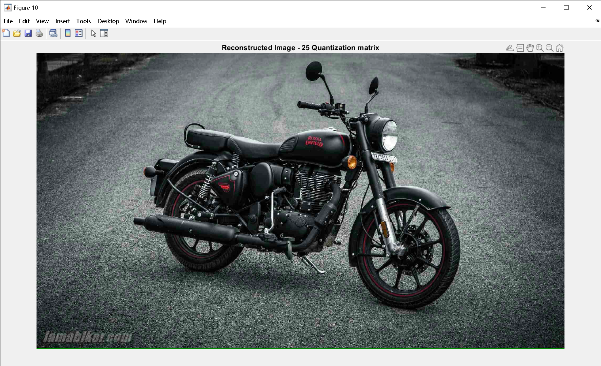

**8. RESULTS AND DISCUSSIONS**

Results obtained after performing DCT of various orders on original images are shown.Fig(3.4.1) shows original images.Images obtained after applying 8 x 8 DCT are as shown in Fig(3.4.2) whereas Fig(3.4.4) shows image obtained for same original image after applying 4 x 4 DCT.Similarly Fig(3.4.6) and Fig(3.4.8) are obtained after applying 8 x 8 DCT and 4 x 4 DCT of the image shown in Fig(3.4.5).Fig(3.4.9) shows the original Lena image.Fig(3.4.10) to Fig(3.4.14) show compressed images for the original Lena image after taking various number of coefficients for quantization.As the number of coefficients increases quality of the image decreases whereas compression ratio continues to increase.Fig(3.4.15) shows that SNR value increases with number of coefficients.

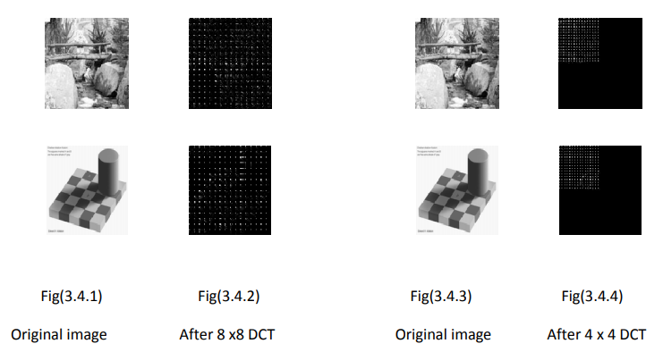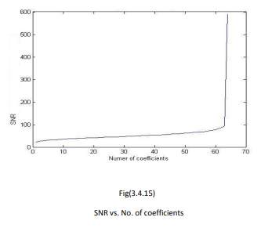

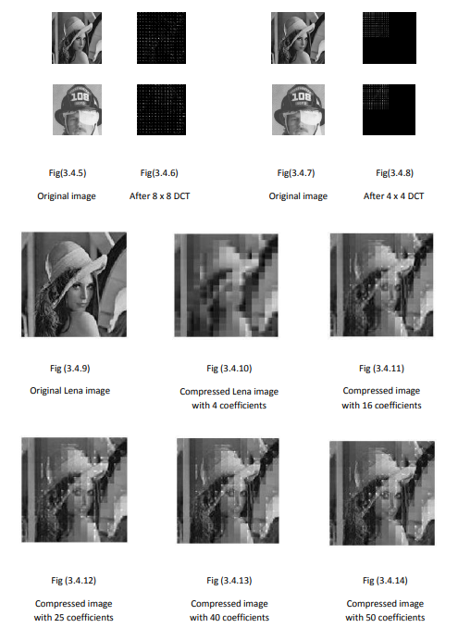

**9. CONCLUSION**

In summary, the code loads a series of images, applies compression using DCT and quantization, performs decompression, and displays both the original and reconstructed images for each image in the loop. It also calculates and prints the compression ratio for each image.

**10. REFERENCES**

1. R. C. Gonzalez and R. E. Woods, “Digital Image Processing”,Second edition,pp. 411-514, 2004.
2. N. Ahmed, T. Natarajan, and K. R. Rao, "Discrete cosine transform," IEEE Trans. on Computers, vol. C-23, pp. 90-93,1974.
3. A. S. Lewis and G. Knowles, "Image Compression Using the 2-D Wavelet Transform" IEEE Trans. on Image Processing, Vol. I . NO. 2, PP. 244 - 250, APRIL 1992.
4. Amir Averbuch, Danny Lazar, and Moshe Israeli,"Image Compression Using Wavelet Transform and Multiresolution Decomposition"IEEE Trans. on Image Processing, Vol. 5, No. 1, JANUARY 1996.
5. M. Antonini , M. Barlaud and I. Daubechies, "Image Coding using Wavelet Transform”,IEEE Trans. On Image Processing Vol.1, No.2, pp. 205 – 220, APRIL 1992.
6. Robert M. Gray,IEEE, and David L. Neuhoff, IEEE"Quantization", IEEE Trans. on Information Theory, Vol. 44, NO. 6,pp. 2325-2383, OCTOBER 1998.(invited paper).
7. Ronald A. DeVore, Bjorn Jawerth, and Bradley J. Lucier, Member,"Image Compression Through Wavelet Transform Coding" IEEE Trans. on Information Theory, Vol. 38. NO. 2, pp. 719-746, MARCH 1992.
8. <http://en.wikipedia.org/Image_compression>
9. Greg Ames,"Image Compression", Dec 07, 2002.

**10.COURSE OUTCOME**

**C06 – Experiment with image/speech processing applications**

Thus, Course outcome 6 is satisfied.